Production/Construction
Wooden toolBox Project

Materials

- 1/2" x 10.25" Dowel Rod: One piece
- 1" x 6" x 35" Oak or other desired Wood: One piece
- 1 1/4" Wood Screws: 8 pieces
- 1/4" Plugs: 6 pieces
- Sandpaper
- Wood Filler and Glue
- Satin Finish Polyurethane
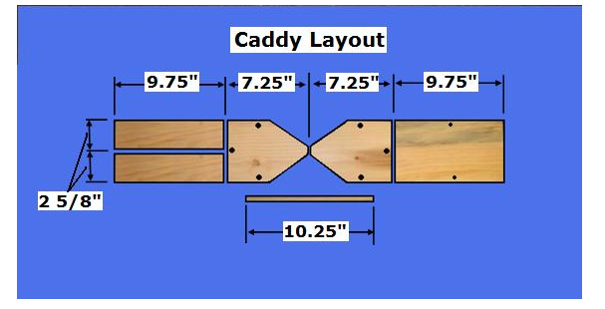
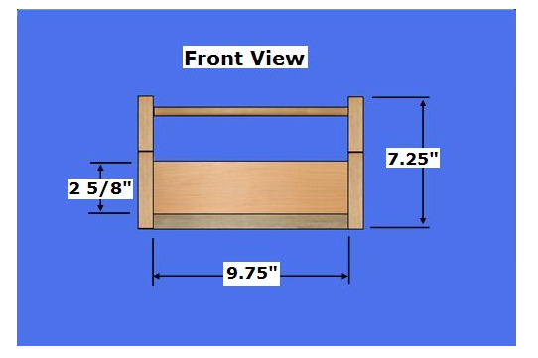
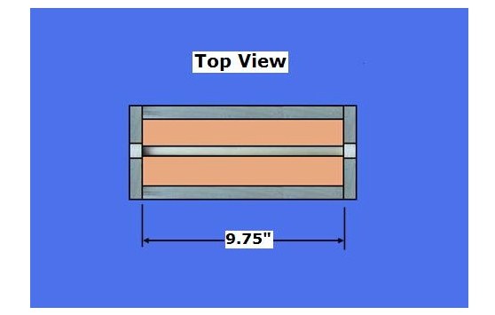

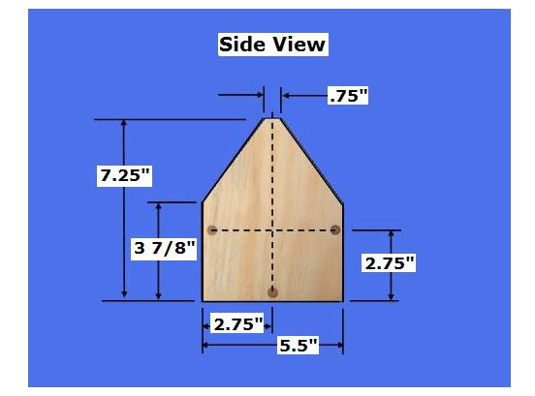

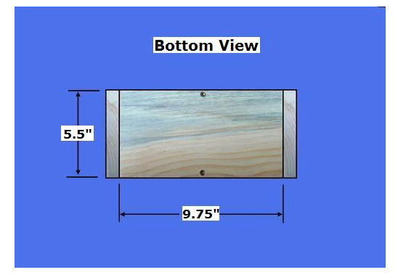

Step 1: Cut the Caddy Pieces - Determine the desired size of your Caddy or use the dimensions provided
- Select the 1 x 6 material; cut the pieces per the dimensions above
- Select the Side and Bottom pieces; Drill three, 1/4" holes (1/4" deep) on each exterior side and two holes in the Bottom Panel per the dimensions above
- Select the two, Side pieces; Drill one, 1/2" hole (1/4" deep) on each interior surface, centered at the top of each side to receive the Dowel Rod
- Select all pieces; Sand all pieces
Step 2: Assemble the Caddy Pieces - Select and dry-fit all pieces
- Attach one Side to the Front, Back, and Bottom Panels with glue and three wood screws, as shown above
- Attach the Bottom Panel; Connect the Bottom Panel to the Front and Back Panels with the wood screws
- Repeat the process for the other side after placing the Dowel Rod in place

