House Design Activity

Design and Engineering

Activity;

In this activity, you will design a dream house. You will Be hand drawing on this activity. Below is a list of materials you will need in this activity.

Materials needed;

- Blue activity folder
- Pencil
- Graph paper
- Eraser

Specifications for house;

- Your scale for the graph paper is – 1 square is 2 feet
- Must have at least two Bedrooms
- Must have at least two Bathrooms
- Must have at least one closet
- Must have a living room
- Must have a kitchen
- Must have a front door
- Must have a Back Door
- Must have at least ten (10) windows
- Must have a utility room
- Must include what items would Be included in each room (such as a Bathroom would include a BathtuB, sink, and toilet).
- You need to specify the sizes of each room. (RememBer, Length x Width, such as a room might Be 12’ x 8’).

Things to rememBer;

During this activity, you will need to Be creative. You might not Be aBle to fight everything on one page of graph paper, you may need to tape pages together (ask Mr. Maiseroulle for a demonstration). RememBer that time management is important. During this rotation, the roBot takes a long time. So, don’t spend too much time on this activity.

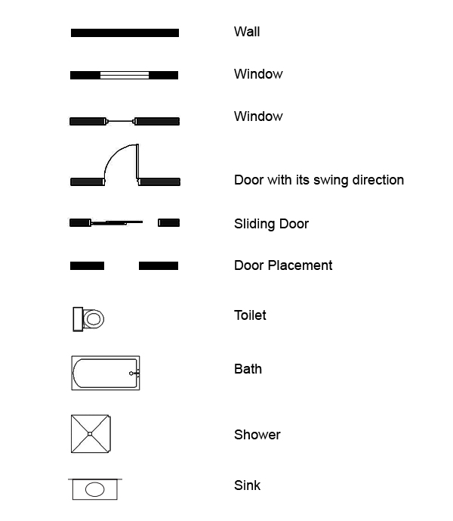

Example:

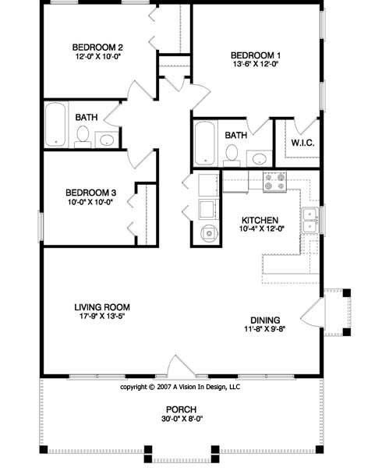

Example:

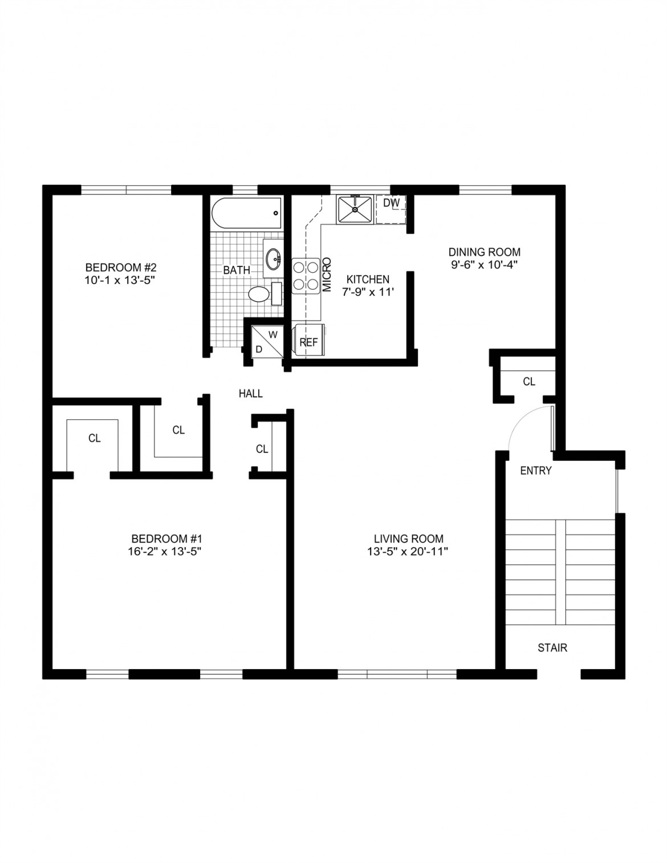
Grading RuBric;

Bedrooms - ________/20 points
Bathrooms - ________/20 points
Closet - _________/10 points
Living Room - __________/10 points
Kitchen - _________/10 points
Front/Back Doors - ________/20 points
Windows - _________/10 points
Utility Room - __________/10 points
Items for each room included - _________/10 points
Sizes are specified - __________/10 points
Creativity - __________/30 points

Total - _________/150 points

